**TINKER CAD – SENSOR DE UMIDADE**

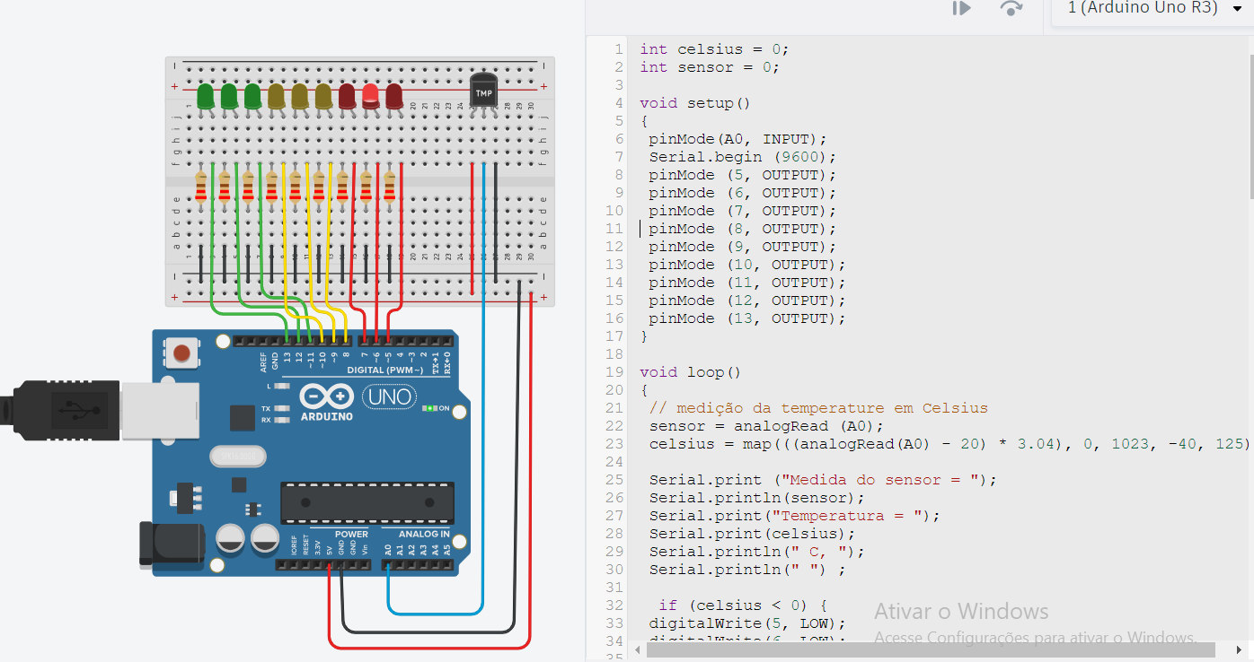

**CODIGO:**

int celsius = 0;

int sensor = 0;

void setup ()

{

pinMode(A0, INPUT);

Serial.begin (9600);

pinMode (5, OUTPUT);

pinMode (6, OUTPUT);

pinMode (7, OUTPUT);

pinMode (8, OUTPUT);

pinMode (9, OUTPUT);

pinMode (10, OUTPUT);

pinMode (11, OUTPUT);

pinMode (12, OUTPUT);

pinMode (13, OUTPUT);

}

void loop()

{

// medição da temperature em Celsius

sensor = analogRead (A0);

celsius = map(((analogRead(A0) - 20) * 3.04), 0, 1023, -40, 125);

Serial.print ("Medida do sensor = ");

Serial.println(sensor);

Serial.print("Temperatura = ");

Serial.print(celsius);

Serial.println(" C, ");

Serial.println(" ") ;

if (celsius < 0) {

digitalWrite(5, LOW);

digitalWrite(6, LOW);

digitalWrite(7, LOW);

digitalWrite(8, LOW);

digitalWrite(9, LOW);

digitalWrite(10, LOW);

digitalWrite(11, LOW);

digitalWrite(12, LOW);

digitalWrite(13, HIGH);

}

if (celsius > 0 && celsius <= 10) {

digitalWrite(5, LOW);

digitalWrite(6, LOW);

digitalWrite(7, LOW);

digitalWrite(8, LOW);

digitalWrite(9, LOW);

digitalWrite(10, LOW);

digitalWrite(11, LOW);

digitalWrite(12, HIGH);

digitalWrite(13, LOW);

}

if (celsius > 10 && celsius <= 20) {

digitalWrite(5, LOW);

digitalWrite(6, LOW);

digitalWrite(7, LOW);

digitalWrite(8, LOW);

digitalWrite(9, LOW);

digitalWrite(10, LOW);

digitalWrite(11, HIGH);

digitalWrite(12, LOW);

digitalWrite(13, LOW);

}

if (celsius > 20 && celsius <= 30) {

digitalWrite(5, LOW);

digitalWrite(6, LOW);

digitalWrite(7, LOW);

digitalWrite(8, LOW);

digitalWrite(9, LOW);

digitalWrite(10, HIGH);

digitalWrite(11, LOW);

digitalWrite(12, LOW);

digitalWrite(13, LOW);

}

if (celsius > 30 && celsius <= 40) {

digitalWrite(5, LOW);

digitalWrite(6, LOW);

digitalWrite(7, LOW);

digitalWrite(8, LOW);

digitalWrite(9, HIGH);

digitalWrite(10, LOW);

digitalWrite(11, LOW);

digitalWrite(12, LOW);

digitalWrite(13, LOW);

}

if (celsius > 40 && celsius <= 50) {

digitalWrite(5, LOW);

digitalWrite(6, LOW);

digitalWrite(7, LOW);

digitalWrite(8, HIGH);

digitalWrite(9, LOW);

digitalWrite(10, LOW);

digitalWrite(11, LOW);

digitalWrite(12, LOW);

digitalWrite(13, LOW);

}

if (celsius > 50 && celsius <= 60) {

digitalWrite(5, LOW);

digitalWrite(6, LOW);

digitalWrite(7, HIGH);

digitalWrite(8, LOW);

digitalWrite(9, LOW);

digitalWrite(10, LOW);

digitalWrite(11, LOW);

digitalWrite(12, LOW);

digitalWrite(13, LOW);

}

if (celsius > 60 && celsius <= 70) {

digitalWrite(5, LOW);

digitalWrite(6, HIGH);

digitalWrite(7, LOW);

digitalWrite(8, LOW);

digitalWrite(9, LOW);

digitalWrite(10, LOW);

digitalWrite(11, LOW);

digitalWrite(12, LOW);

digitalWrite(13, LOW);

}

if (celsius > 70) {

digitalWrite(5, HIGH);

digitalWrite(6, LOW);

digitalWrite(7, LOW);

digitalWrite(8, LOW);

digitalWrite(9, LOW);

digitalWrite(10, LOW);

digitalWrite(11, LOW);

digitalWrite(12, LOW);

digitalWrite(13, LOW);

}

delay(500);

}